Module 6 Activity 2: Deploying Node.JS application into Docker Using Visual Studio

Brandon Trinkle

IFT 458: Middleware Programming

Professor Dinesh Sthapit

March 29, 2025

Module 6 Activity 2: Deploying Node.JS application into Docker Using Visual Studio

Task 1: Showing Docker version in the terminal.
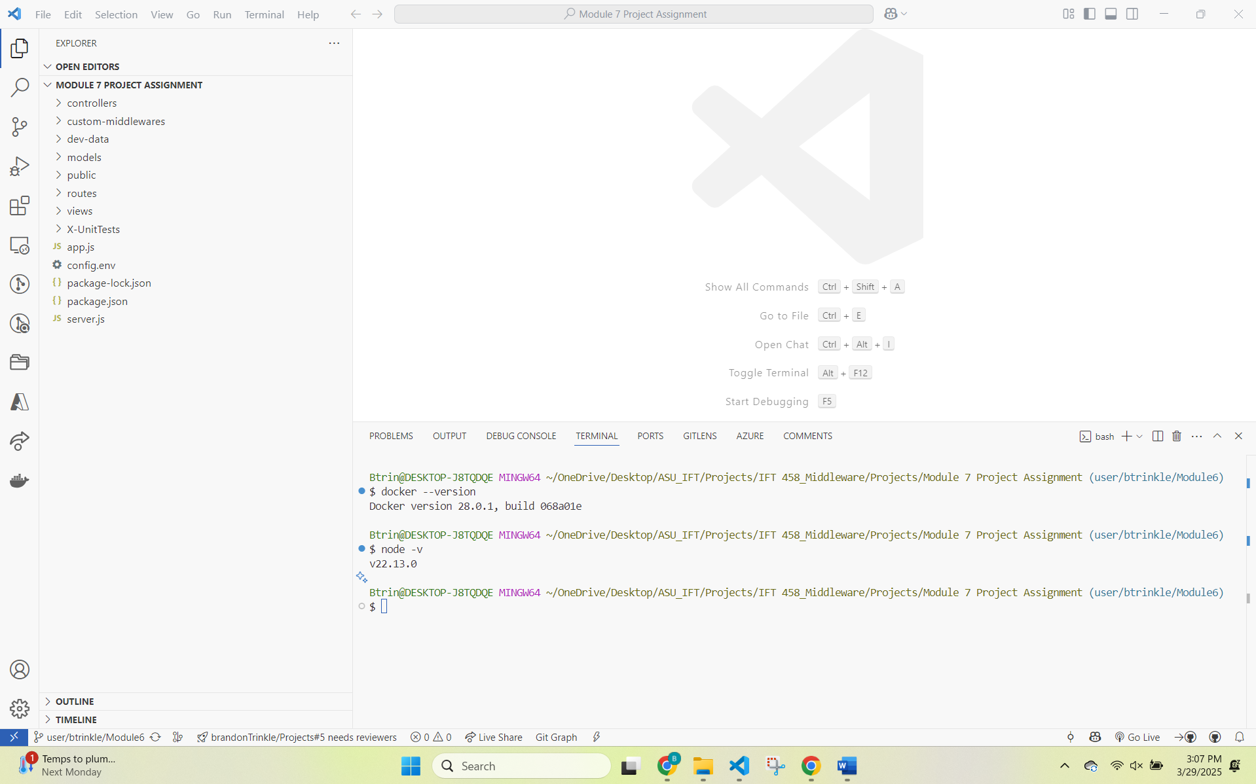

Task 2: Showing Node.js version in the terminal.


Task 3: Displaying Docker extension in VS Code.
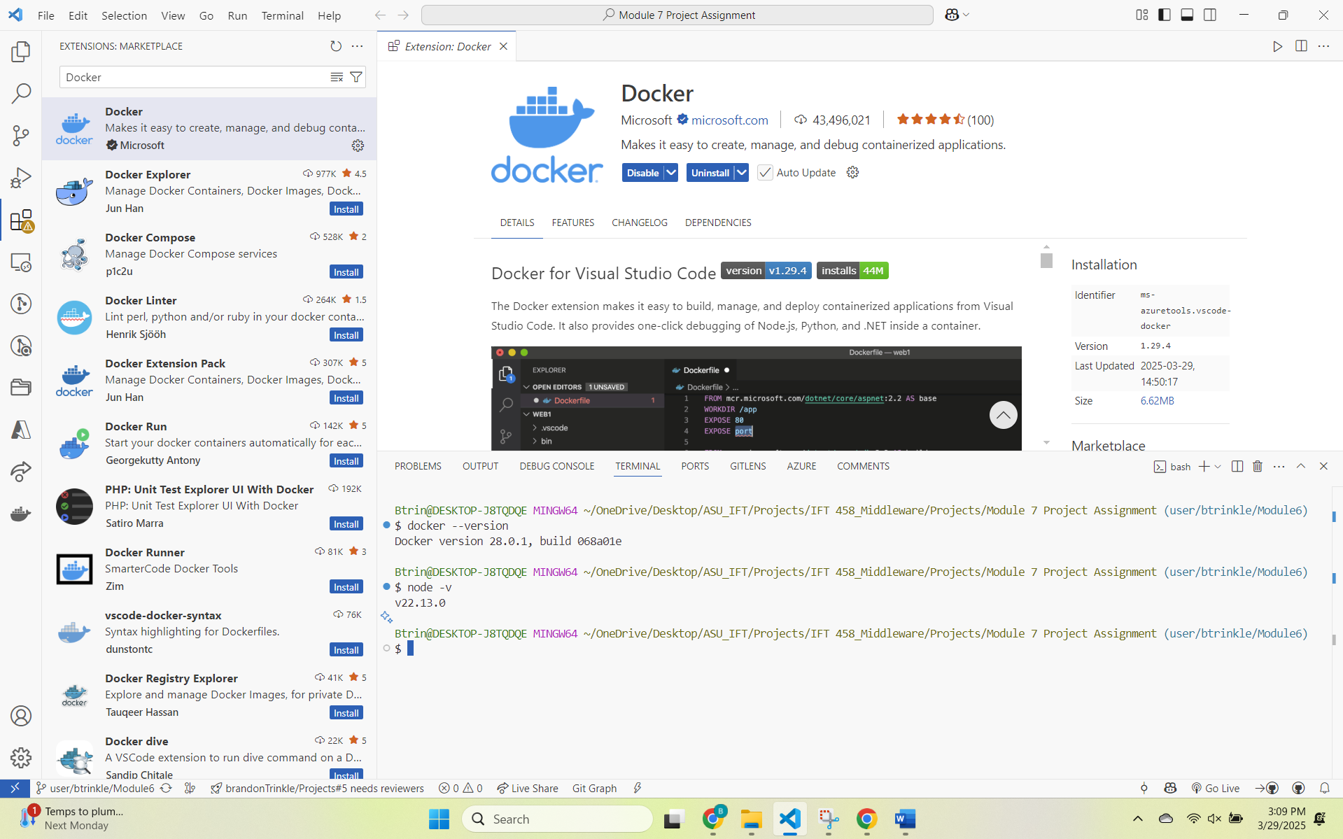

Task 4: Of the running Docker Desktop application.
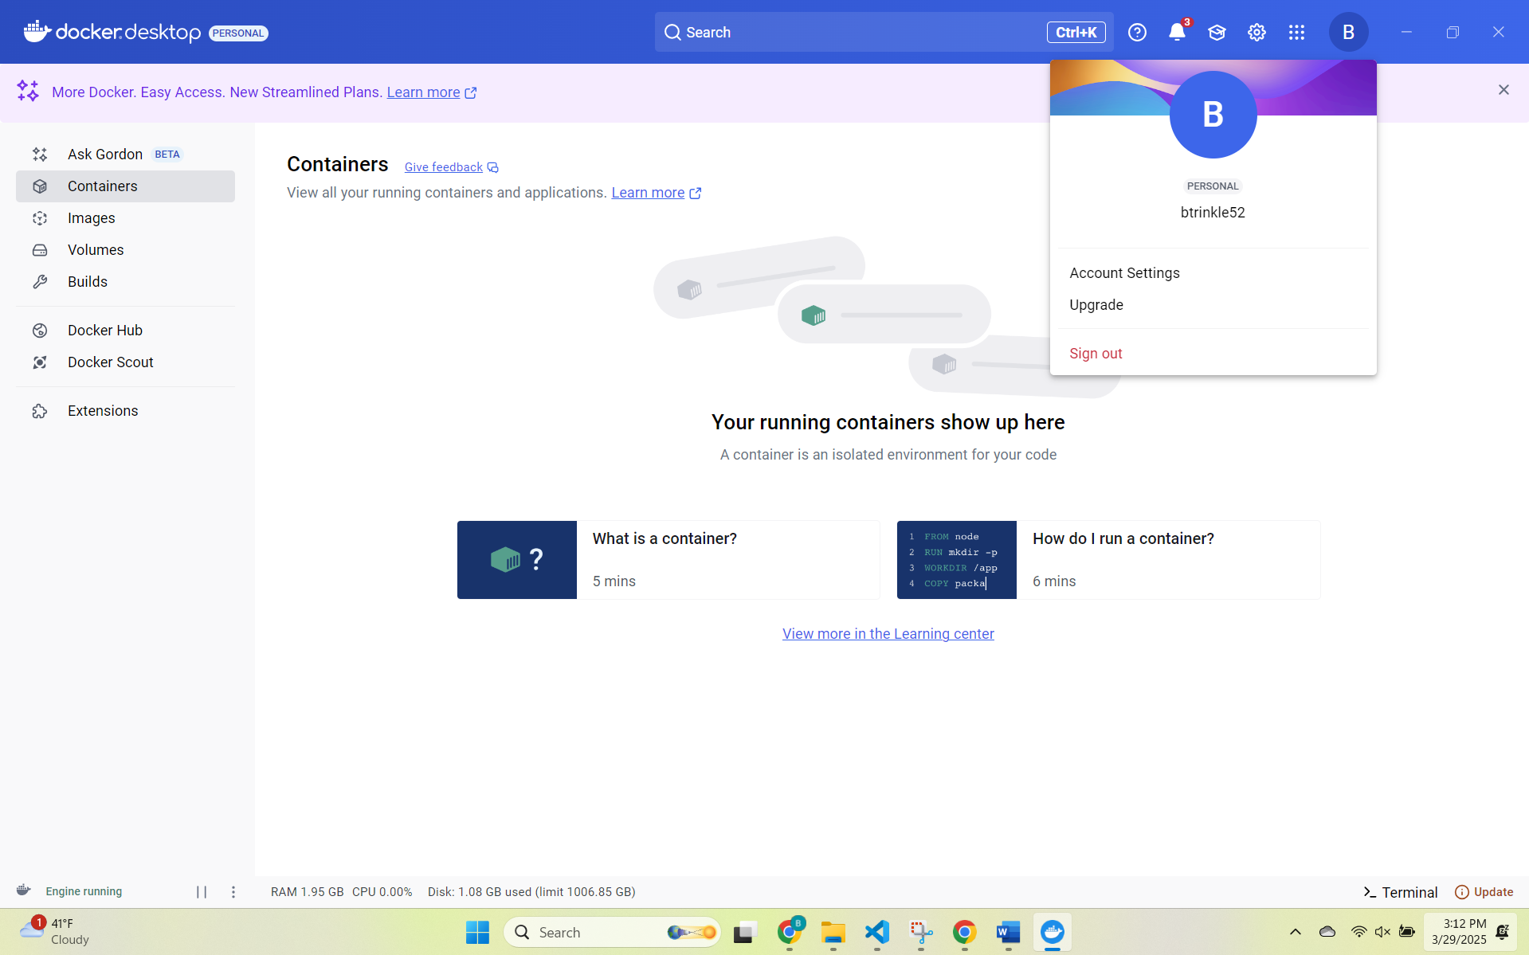

Task 5: Showing successful installation of dependencies in the terminal.
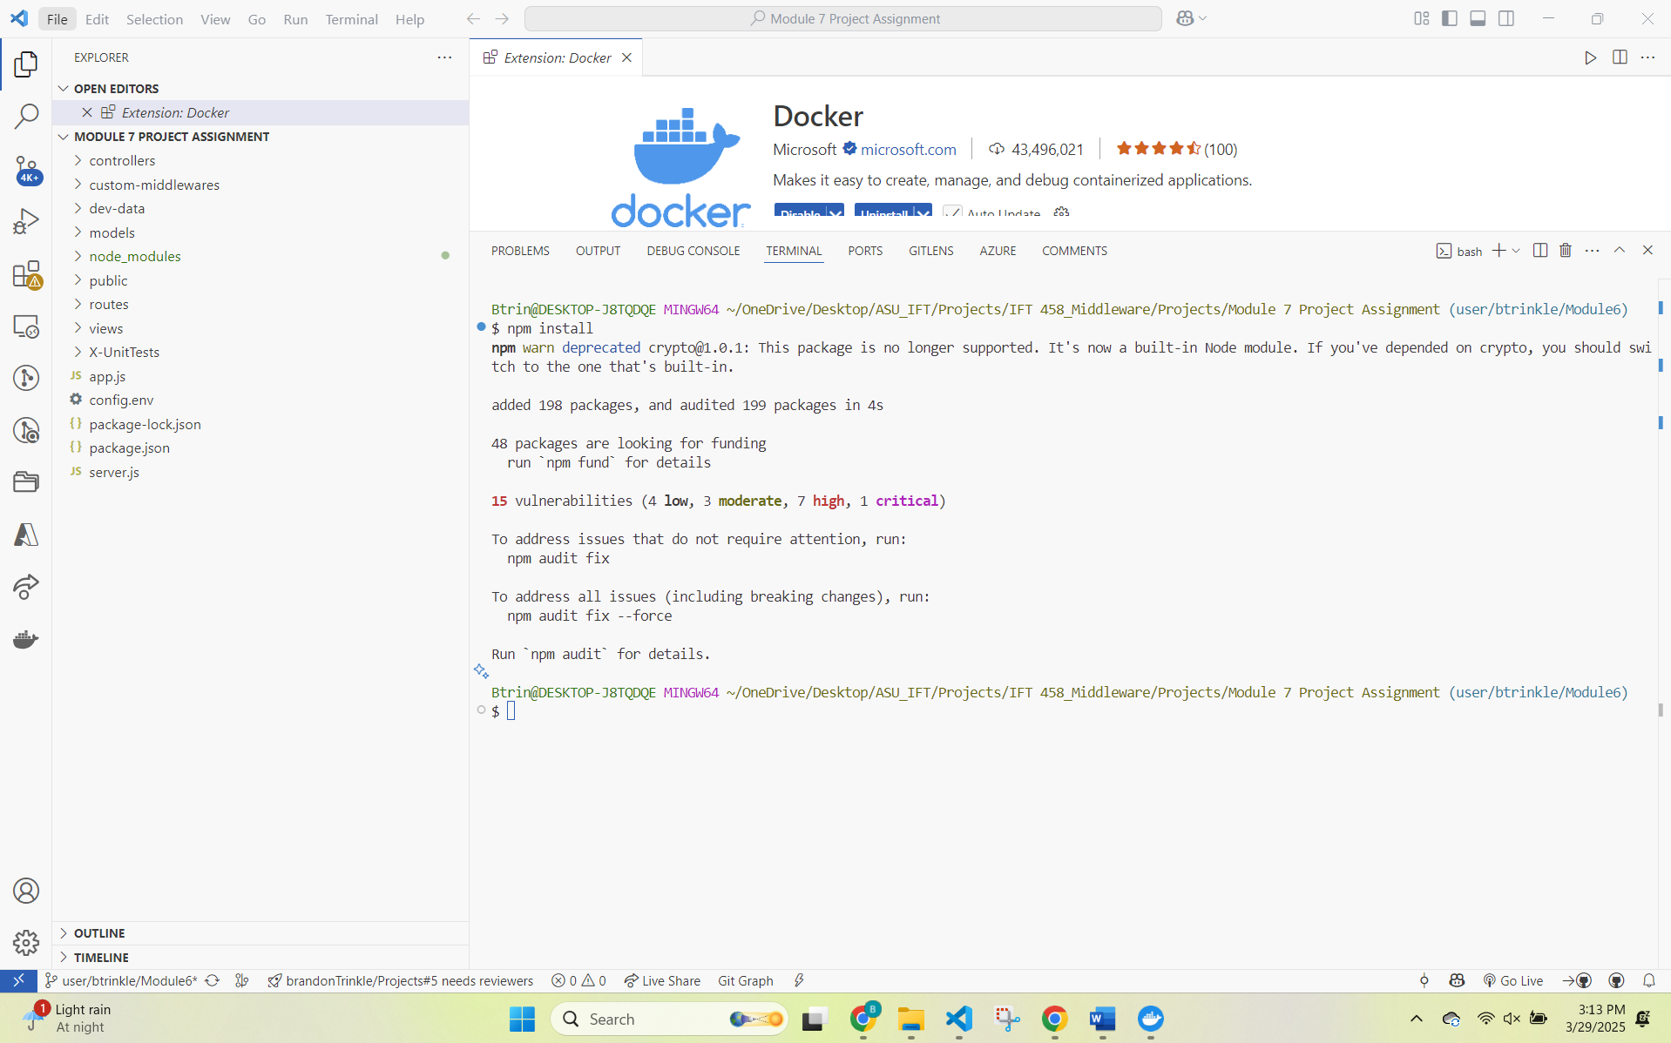

Task 6: Of the Dockerfile with content in VS Code.
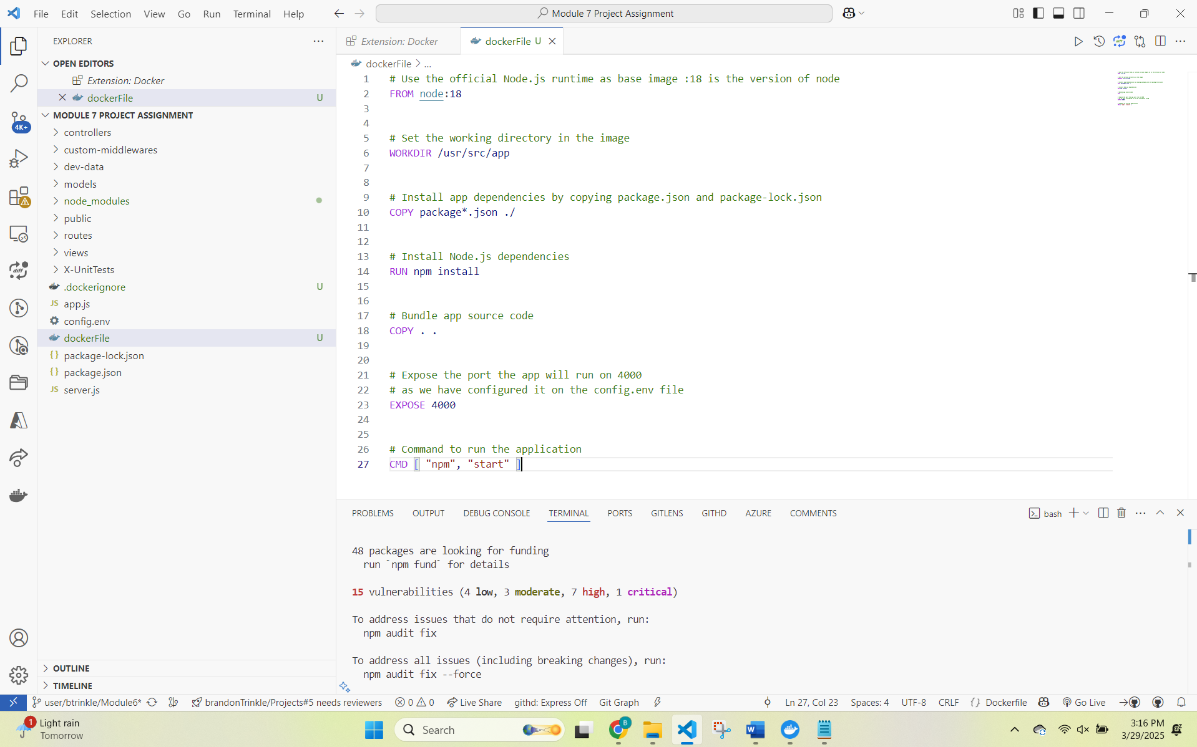

Task 7: Showing the Docker image build process in VS Code.
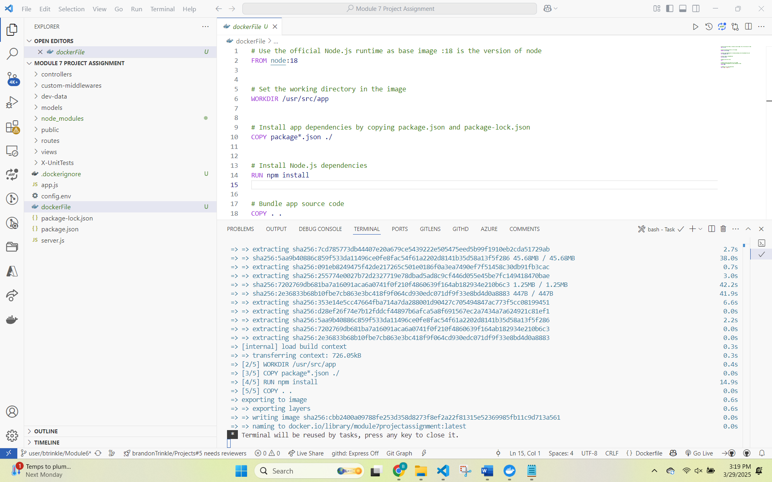

Task 8: Showing Docker container configuration
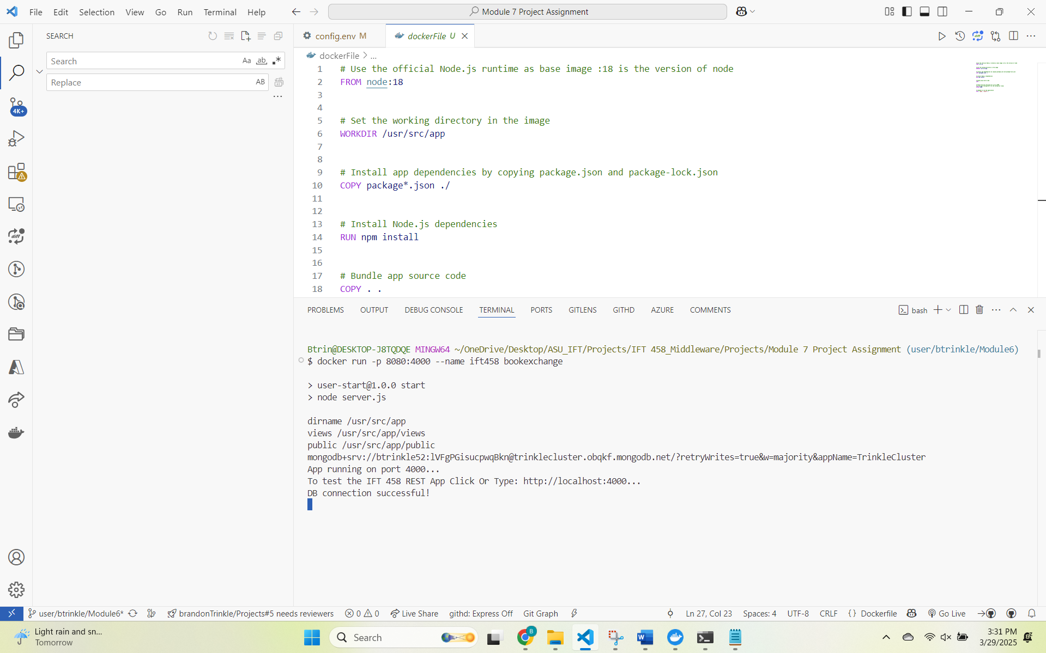
Task 9: Showing the running container in Docker Desktop.
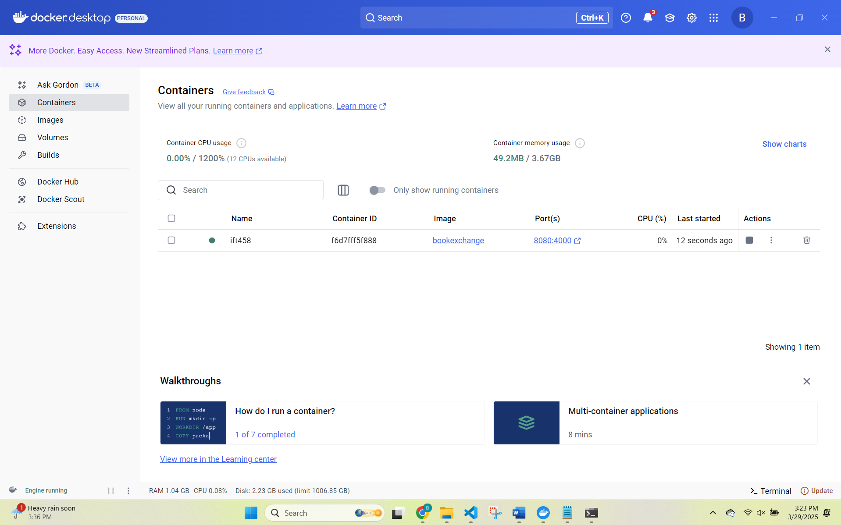
Task 10: Of the running Node.js application in the browser.
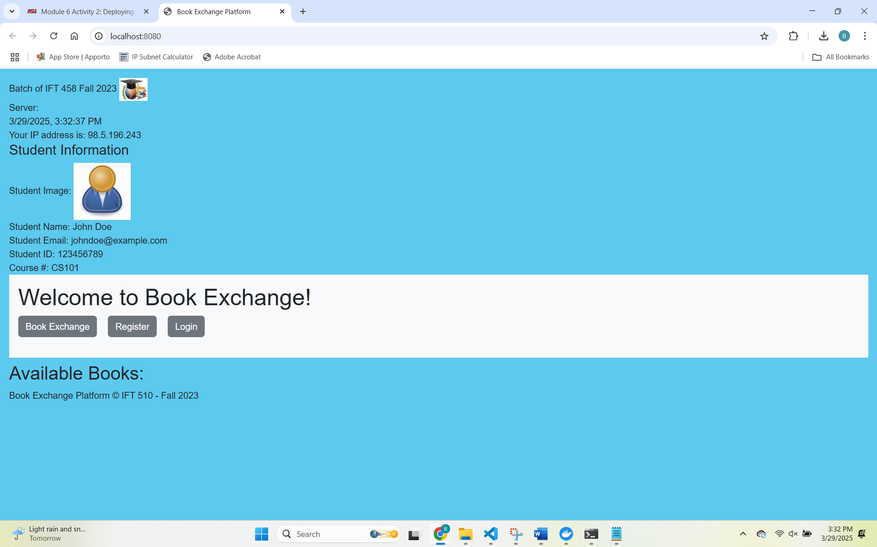
Task 11: Of the terminal after executing the Docker run command.
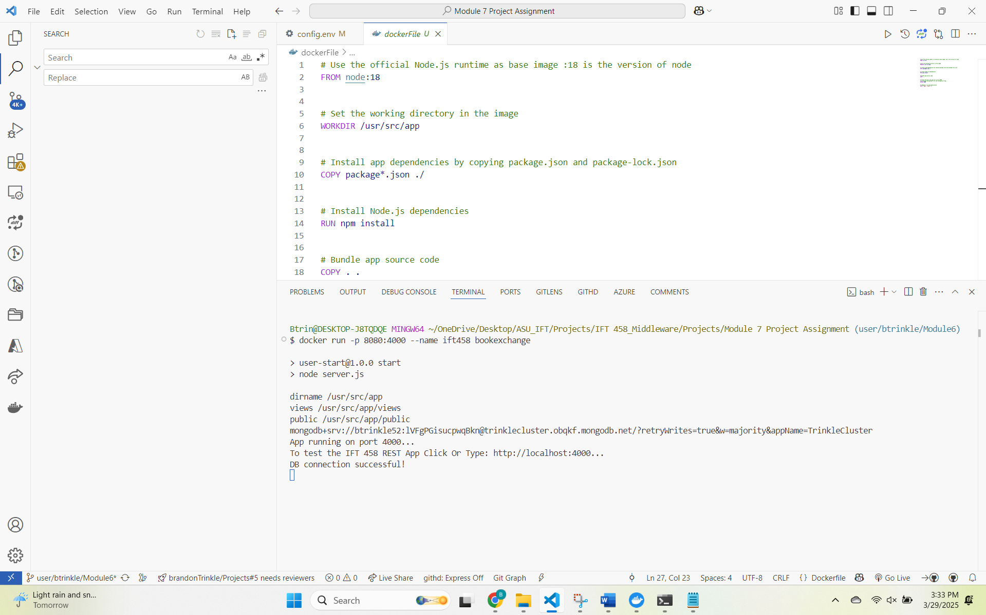
Task 12: Of the interactive shell session with the running Docker container.

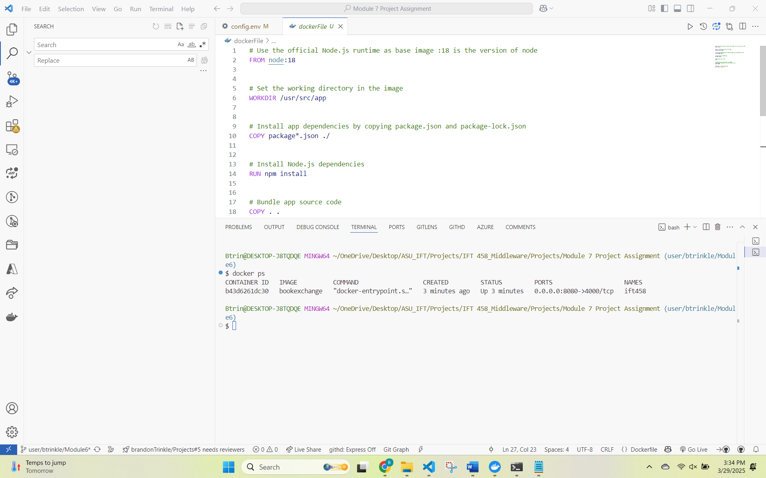
Task 13: Showing the terminal after stopping the container.
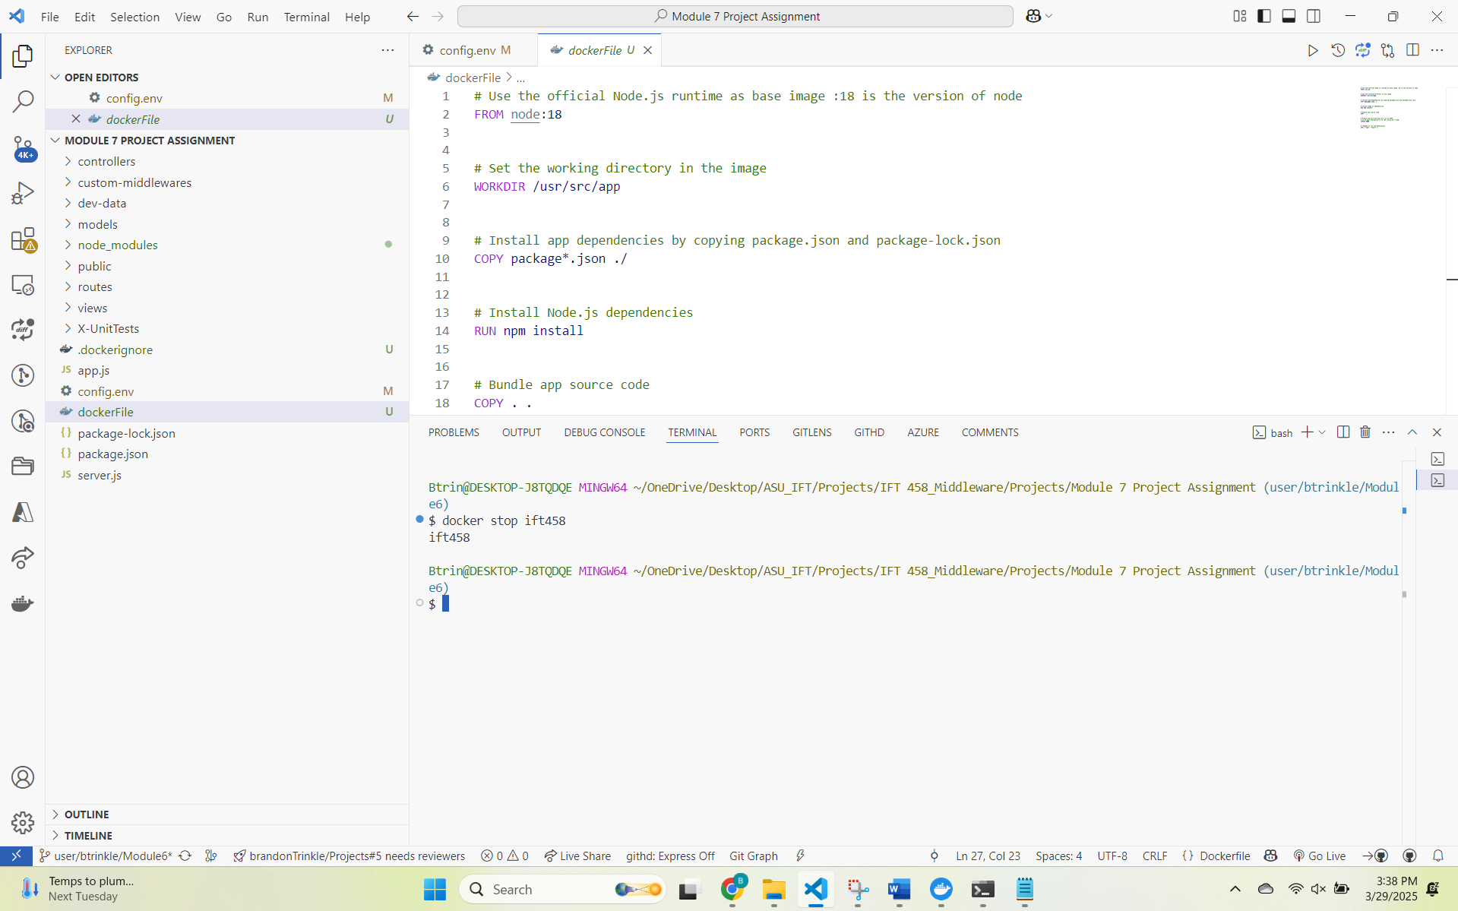
Task 14: Showing the terminal after removing the container.
